**Noun Extraction:**

Note: Nouns are extracted from project proposal.

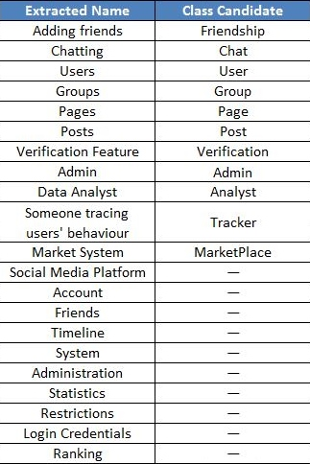

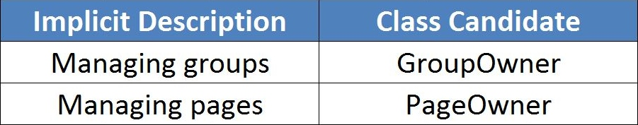**Classes described implicitly:**

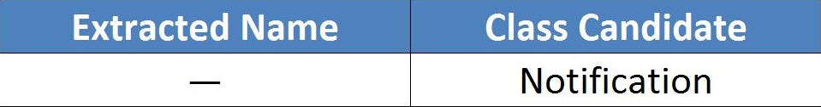**Classes added later on with work (Extra Classes):**